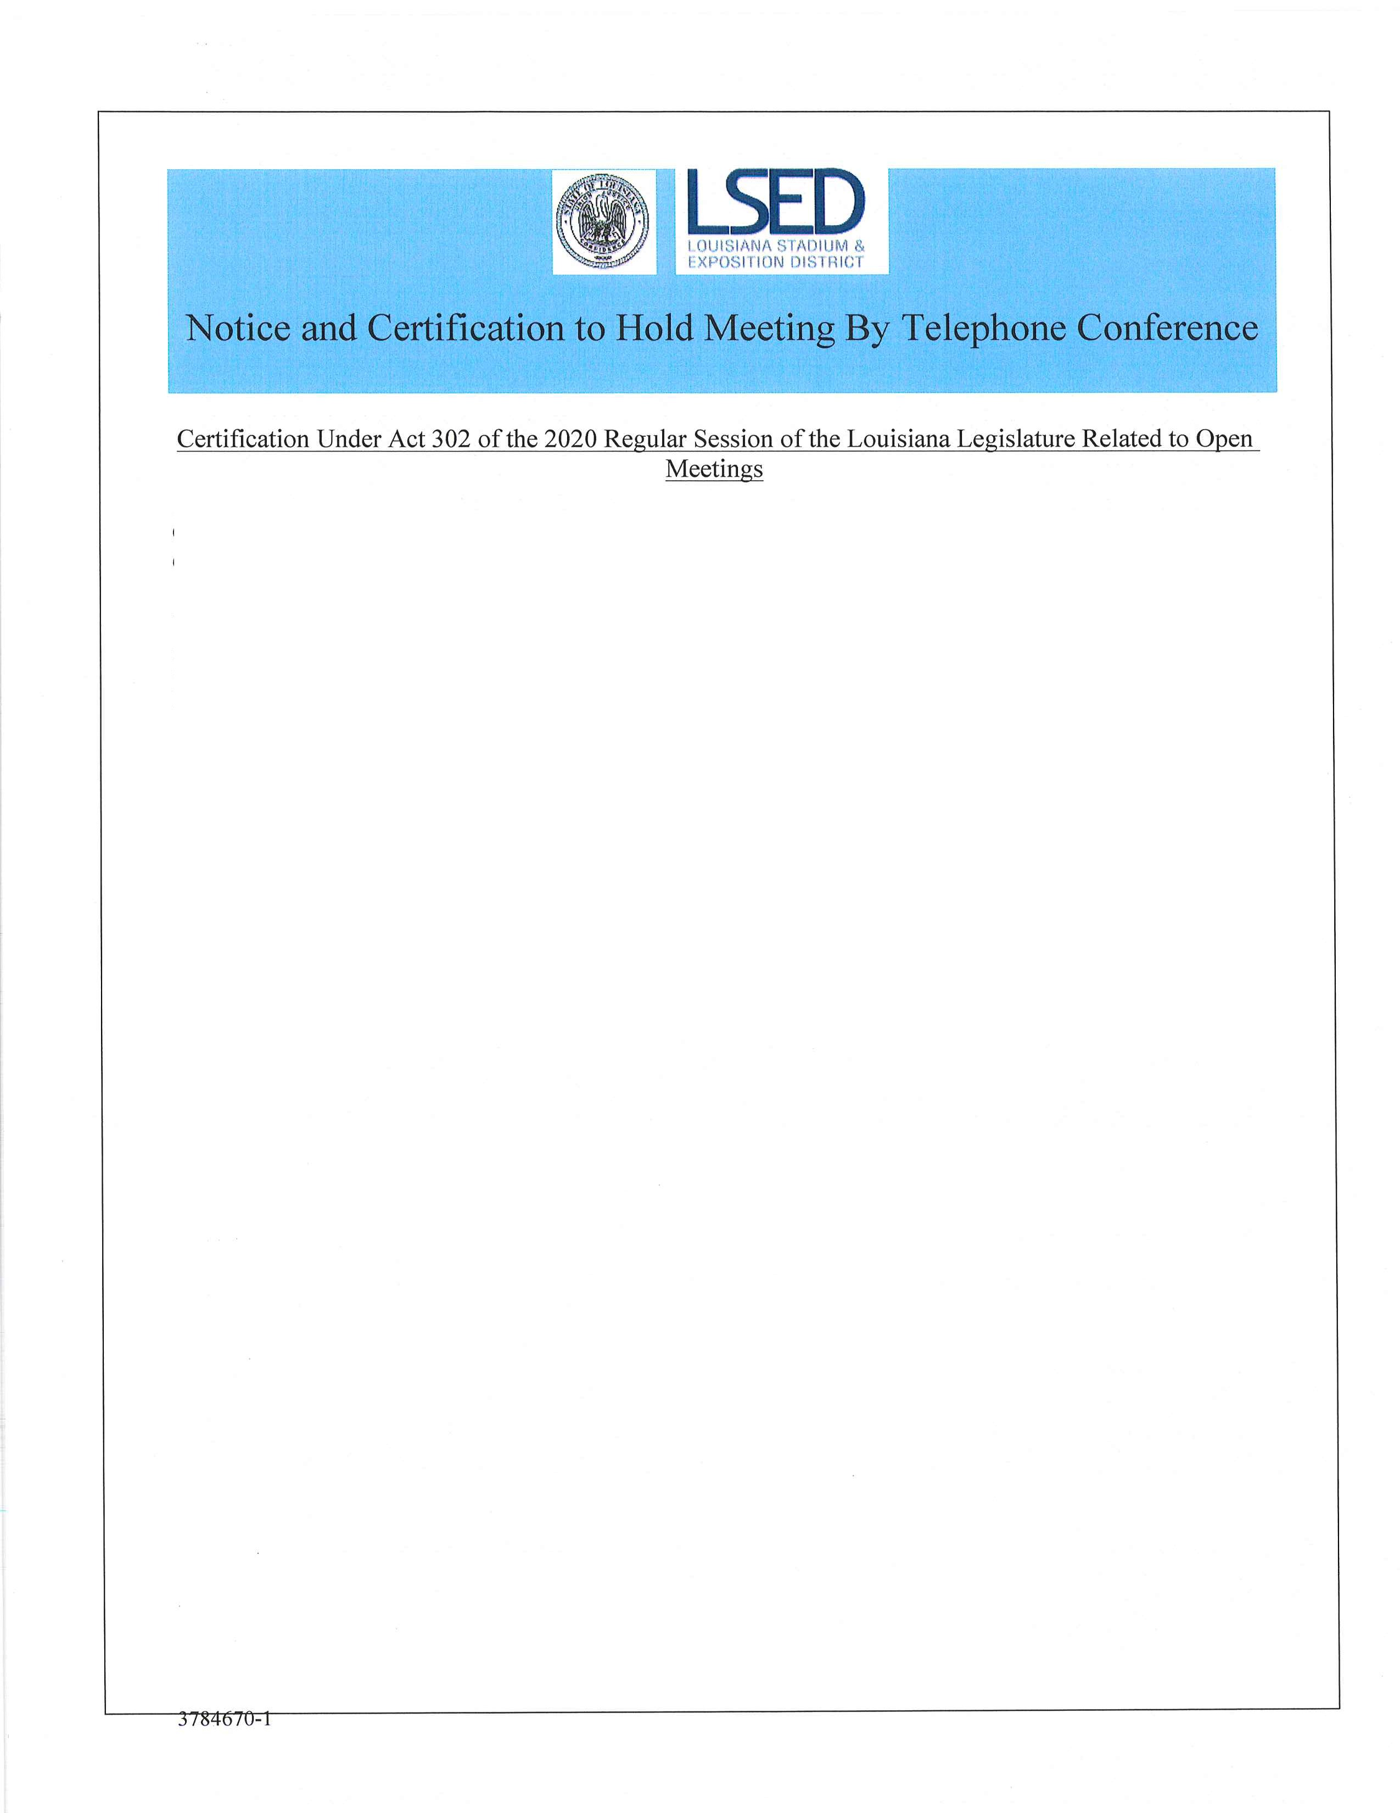

On March 11, 2020, Governor John Bel Edwards declared a public health emergency in response to COVID-19. See Proclamation Number 25 JBE 2020.

The Louisiana Stadium and Exposition District (LSED) is unable to operate due to quorum requirements. Therefore, under Act No. 302 of the 2020 Regular Session of the Louisiana Legislature, the LSED will conduct the Thursday, November 19, 2020 regular monthly meeting of the Board of Commissioners via telephone conference. The public is invited to observe and provide input to the LSED via email. The board meeting agenda (that contains the telephone conference dial-in information) will be posted twenty four (24) hours before the meeting as required by law.

The Louisiana Open Meetings law provides the public an opportunity to comment on any agenda it ems before the Commission. The LSED will accept public comments for the meeting via email only. A person may email a comment related to a particular actionable agenda item until 12:00 p.m., Thursday, November 19, 2020. This email will then be read aloud by the Chairman at the meeting. Email comments should be sent to: LSEDboardmeetings@asmneworleans.com. Please include your name and the agenda item that pertains to your comment. Further in accordance with Act 302, the presiding officer hereby certifies that the meeting agenda is limited to matters set forth in Louisiana Revised Statute 42:17.1 (A)(2)(a-c).

